Day 21 Snake Game Part 2 inheritance and list slicing

<https://www.udemy.com/course/100-days-of-code/learn/lecture/20361125#overview>

Classes can inherit from other classes



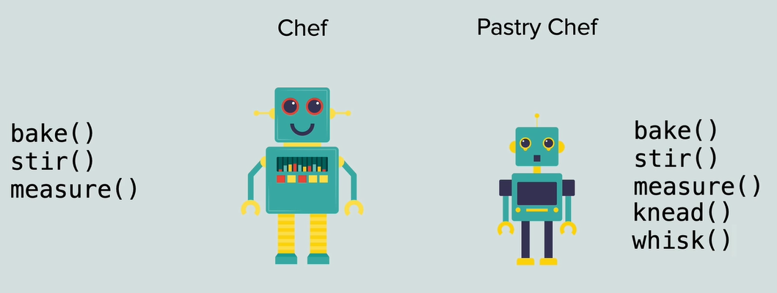

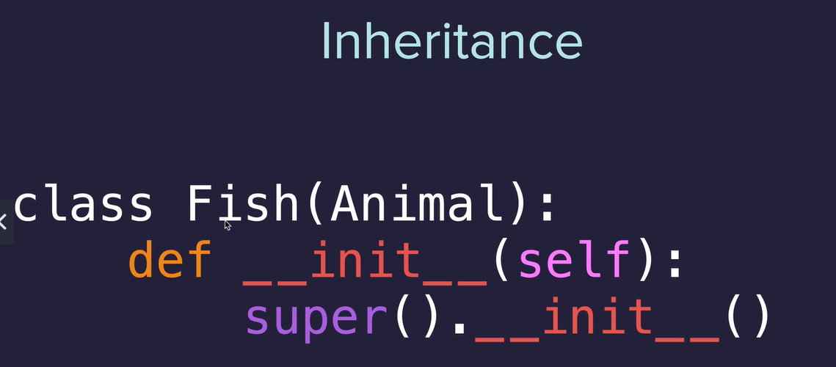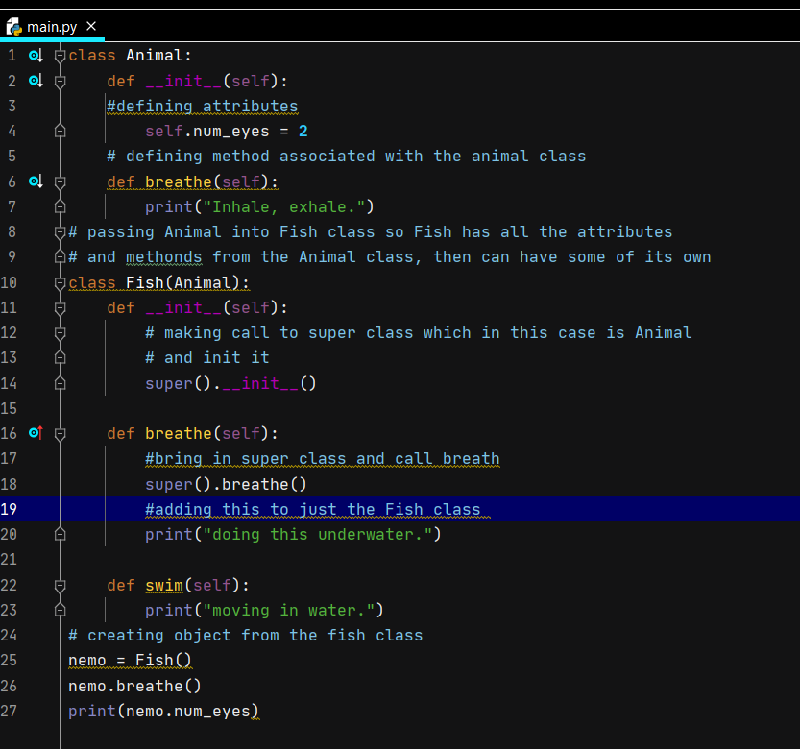

Detect Collision with food

<https://docs.python.org/3/library/turtle.html#turtle.shape>

When snake touches food it jumps to new random location

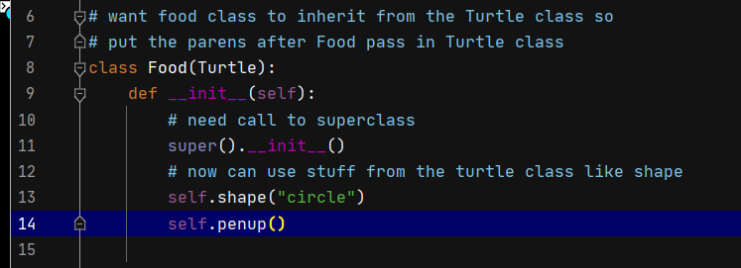

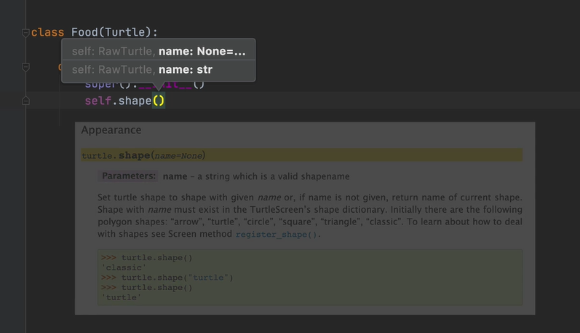

Normaly 20 x20 pixels so make ½ that by using 0.5

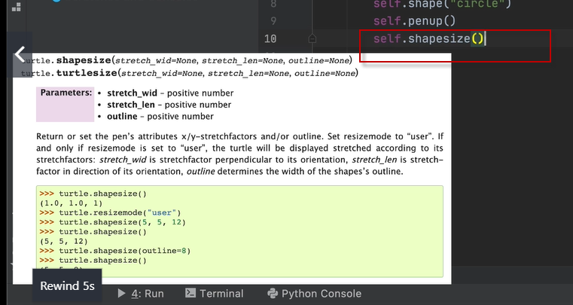

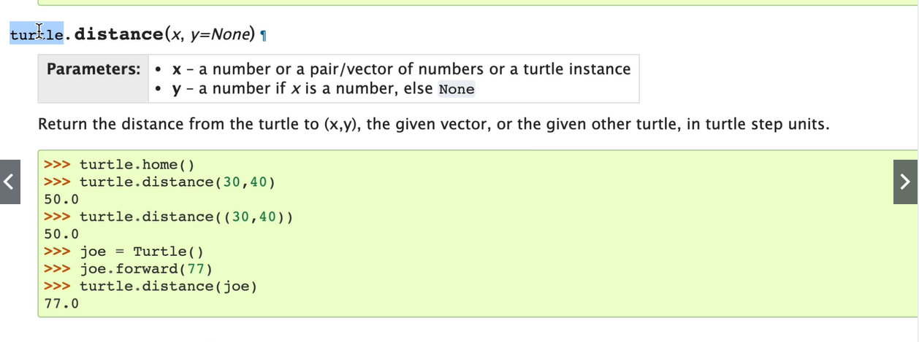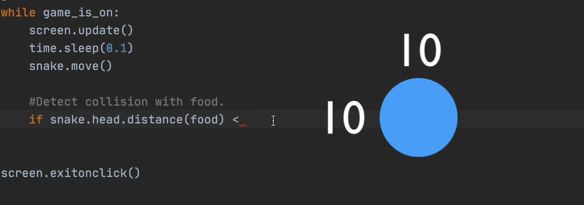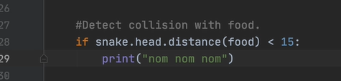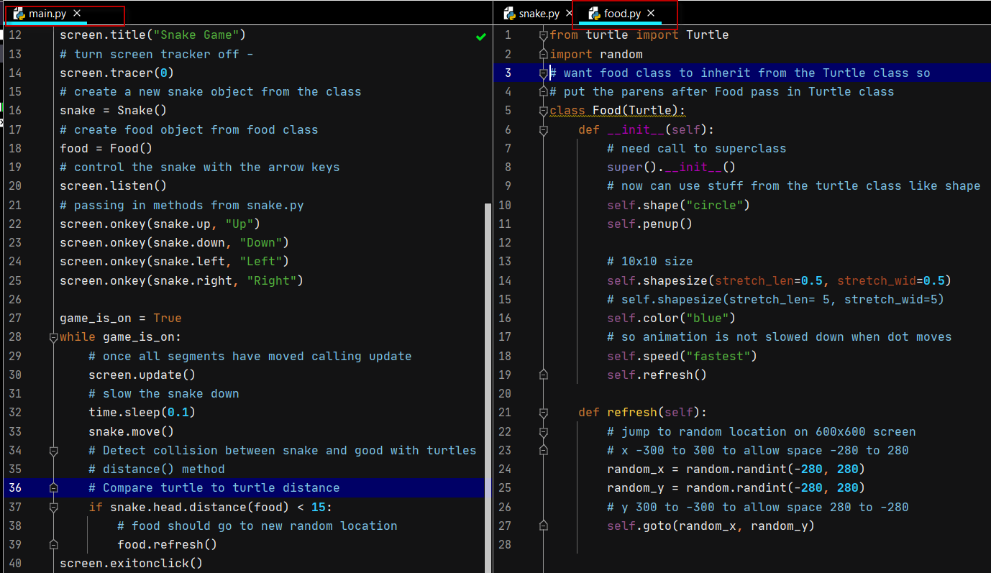

Create scoreboard

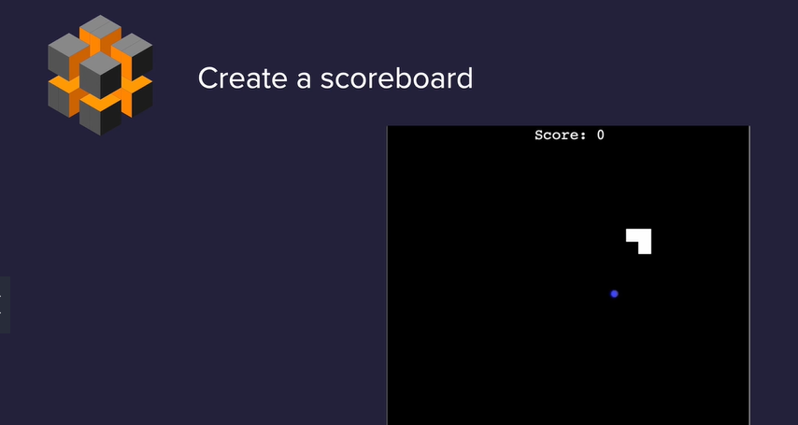

Scoreboard will be a turtle – turtles can write to screen 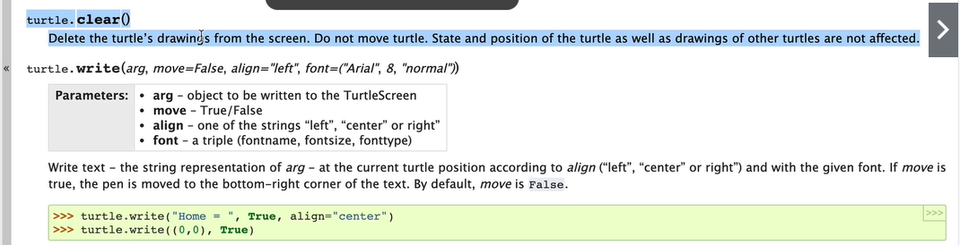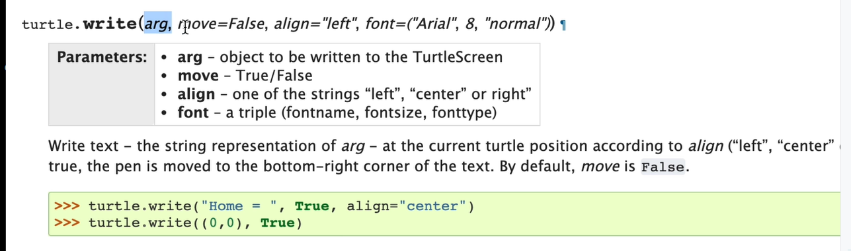

Scoreboard class

from turtle import Turtle

ALIGNMENT= ("center")

FONT =("Courier", 24, "normal")

*class* Scoreboard(*Turtle*):

*def* __init__(*self*):

        super().__init__()

        self.goto(0, 270)

        self.score = 0

        self.color("white")

        self.update_scoreboard()

        self.hideturtle()

*def* update_scoreboard(*self*):

        self.write(*f*"Score = {self.score}", *align*=ALIGNMENT, *font*=FONT)

*def* increase_score(*self*):

        self.score += 1

        self.clear()

        self.update_scoreboard()

Hitting wall – need to play around with to get the correct number for close to wall but not over.

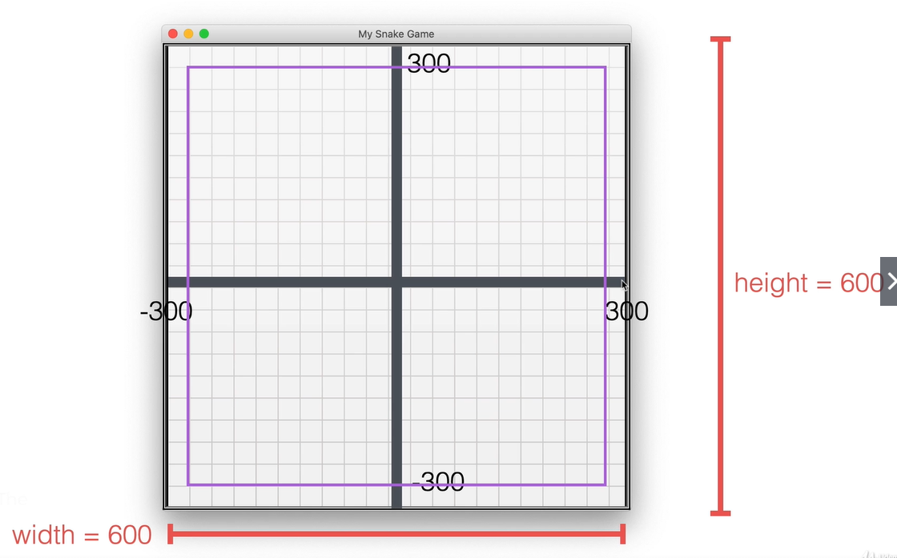

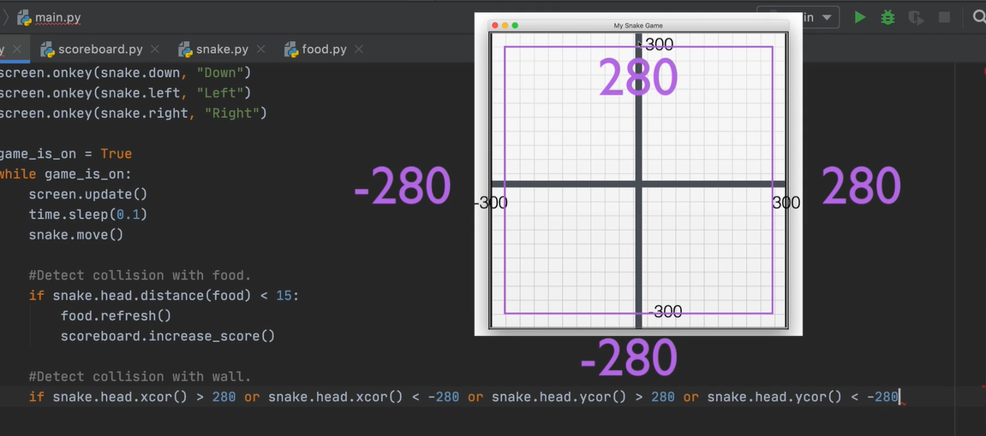

Growing the snake when it meets food.

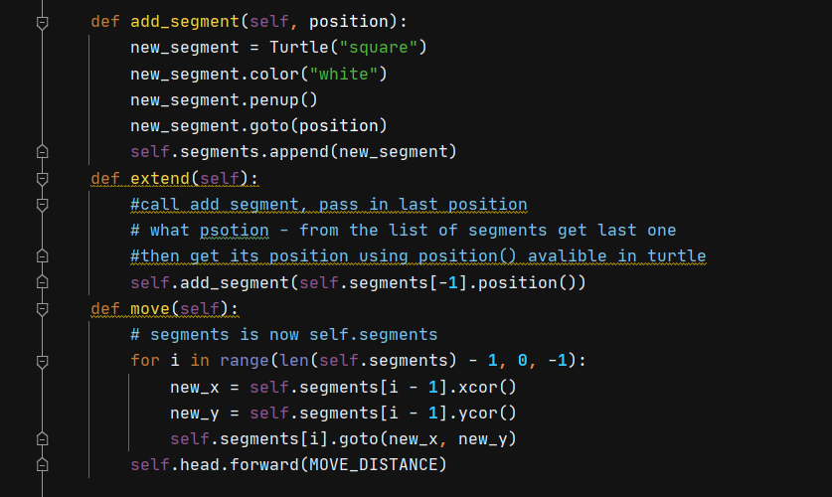

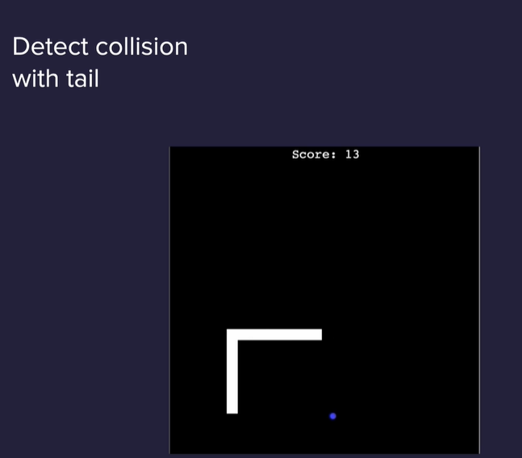

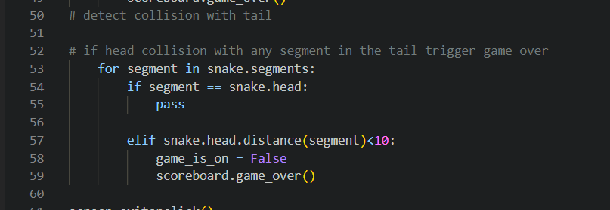

How to slice lists and tuple in python 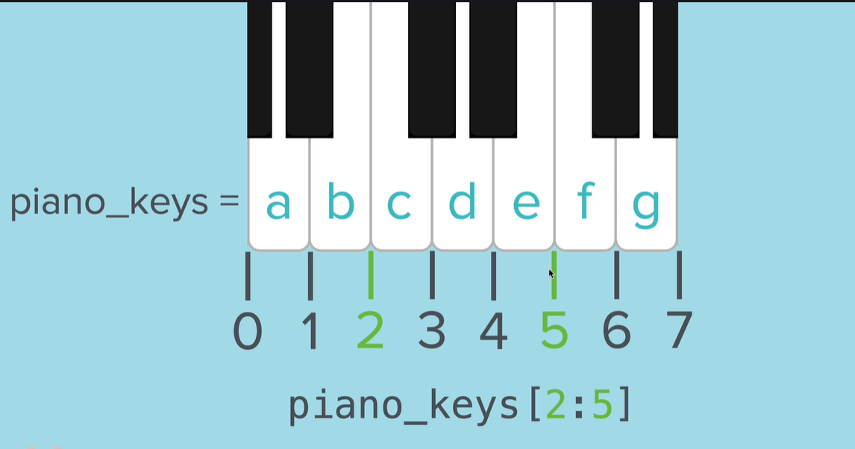

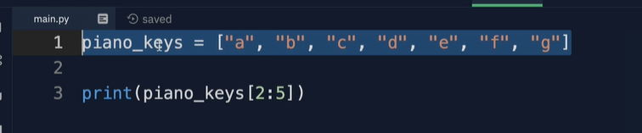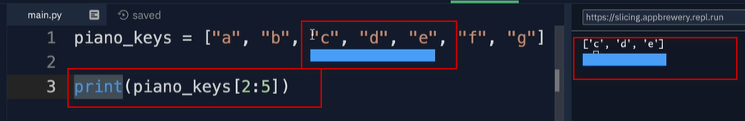

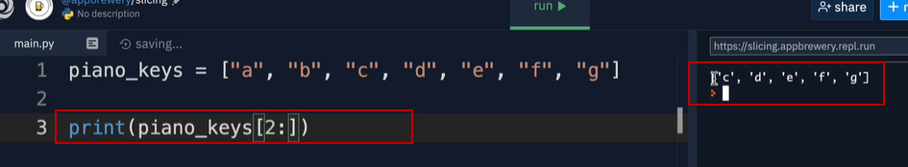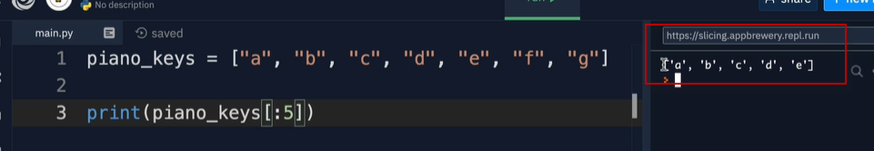

Can pass in a third number to set the increment

2 here gives every other item between 2:5



Every other item in the entire list

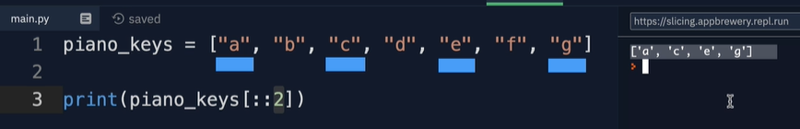

Passing in a -1 reverses the list

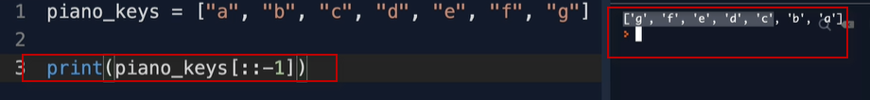

Slice also works with tupples 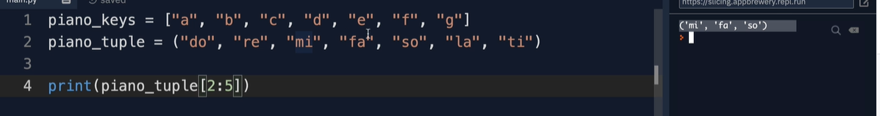

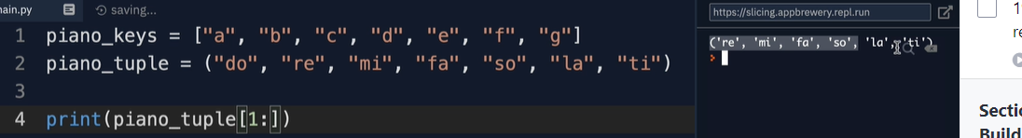

In snake game 